**DAILY ONLINE ACTIVITIES SUMMARY**

|  |  |  |  |  |  |  |  |  |
| --- | --- | --- | --- | --- | --- | --- | --- | --- |
| **Date:** | **11-7-2020** | | | | | **Name:** | **poojashree** | |
| **Sem & Sec** | **8th sem A sec** | | | | | **USN:** | **4al16cs065** | |
| **Online Test Summary** | | | | | | | | |
| **Subject** | |  | | | | | | |
| **Max. Marks** | |  | | **Score** | | |  | |
| **Certification Course Summary** | | | | | | | | |
| **Course** | **Introduction to cyber security** | | | | | | | |
| **Certificate Provider** | | | **Great learning academy** | | **Duration** | | | **5.5hr** |
| **Coding Challenges** | | | | | | | | |
| **Problem Statement:** 1. Python Program to check if given array is Monotonic | | | | | | | | |
| **Status:completed** | | | | | | | | |
| **Uploaded the report in Github** | | | | | **yes** | | | |
| **If yes Repository name** | | | | | **Poojashree** | | | |
| **Uploaded the report in slack** | | | | | **yes** | | | |

**Online test**

**----------no marks -----------**

**Certification course**

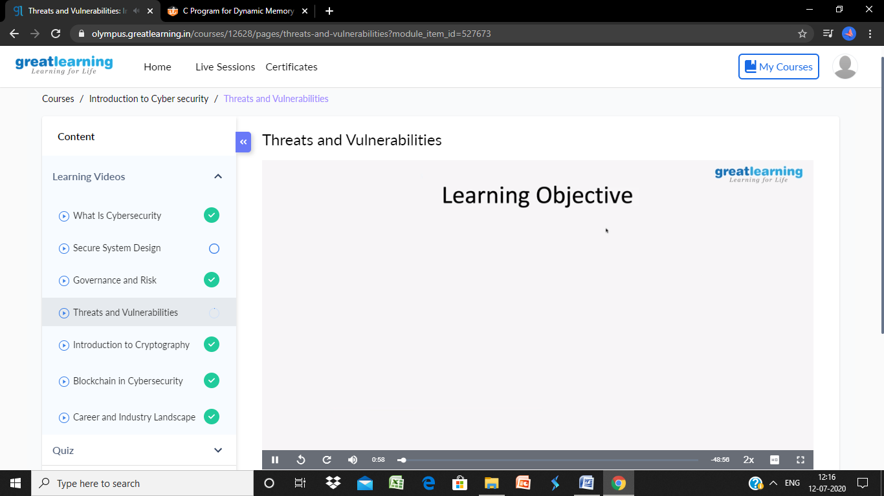

**Coding**

**Program 1**

def isMonotonic(A):

    return (all(A[i] <= A[i + 1] for i in range(len(A) - 1)) or

            all(A[i] >= A[i + 1] for i in range(len(A) - 1)))

# Driver program

A = [6, 5, 4, 4]

# Print required result

print(isMonotonic(A))